# freETarget

Application Note: Installing the Target Light

**SUMMARY**

This application note covers the steps needed to install the target light.

**REQUIRED**

* freETarget Version 3.0 or higher
* freETarget Firmware 3.0.3 or higher
* freETarget PC program X.XX or higher

**INTRODUCTION**

Version 3.0 of freETarget supports a variable brightness LED for target illumination. It uses a standard LED strip that can be purchased locally at a hardware store

**PREPARATION**

* To Purchase: Under cabinet LED strip.
  + Home Depot Model LS2835-8F or similar
  + Strip light, 12VDC Supply
* Tools:
  + Drill
  + Screw Driver
  + Screws
  + Washers or similar

**INSTRUCTIONS**

* Mount the LED strip as shown in Figure 1:

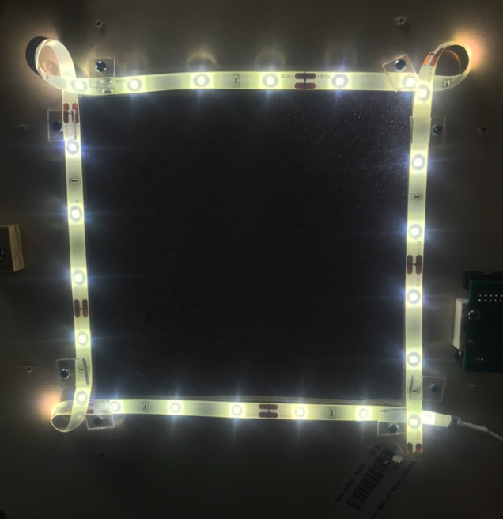

Figure 1: Installing the LED strip.

* + Note, the LED strip does not bend well and wrapping in a loop in the corners simplifies the installation
  + Be careful not to cut into the LED strip
  + Trim to length when finished.
* Determine the location on the power cable where to cut the wire to attach to the screw terminal.
  + Provide enough slack to open and close the door without stressing the wires
* Cut the wire to length, and strip the ends by 5 mm
* Measure and record the voltage. This is important for the next step. Failure to do so correctly may damage the board beyond repair
* Install the wires into the screw terminals as shown in Figure 2

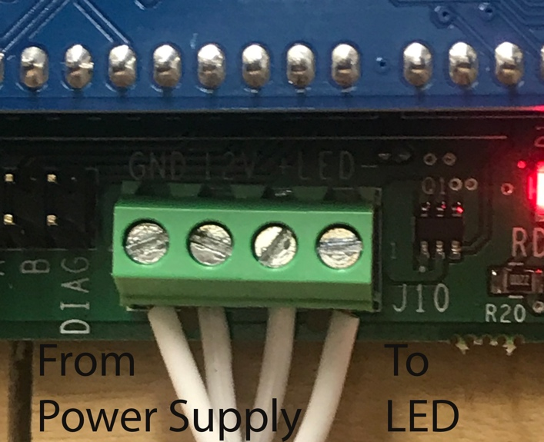

Figure 2: LED Wire Installation

* Reading left to right, the connections are

|  |
| --- |
| Left |
| Power Supply -Voltage (Ground) |
| Power Supply +Voltage (12VDC) |
| LED Positive Lead |
| LED Ground Lead |
| Right |

* From the PC program Set-Up, set the LED illumination to the desired level. The brightness level is set to 50% by factory default.

**TROUBLE SHOOTING**

* Verify that the LED power supply is plugged in
* Verify that the wires are connected in the correct order
* Verify that the wires are tight and do not fall out
* Verify that the LED level is set correctly
* Ensure that the LED strip has not been damaged during the installation